K537 TOP414G 35721A

Ref: #21

IRFP250N G3 DB

Ref: #19

CRLNLMG1 32B1M

Ref: #17

431AV PAHF

Ref: #5

55 84 K0

Ref: #6

7438 543C

G68V

Ref: #11

K0204 FQA

70N15

Ref: #20

PVI 1050 NS

0538I4N

Ref: #24

IR 2136S 0515

Ref: #18

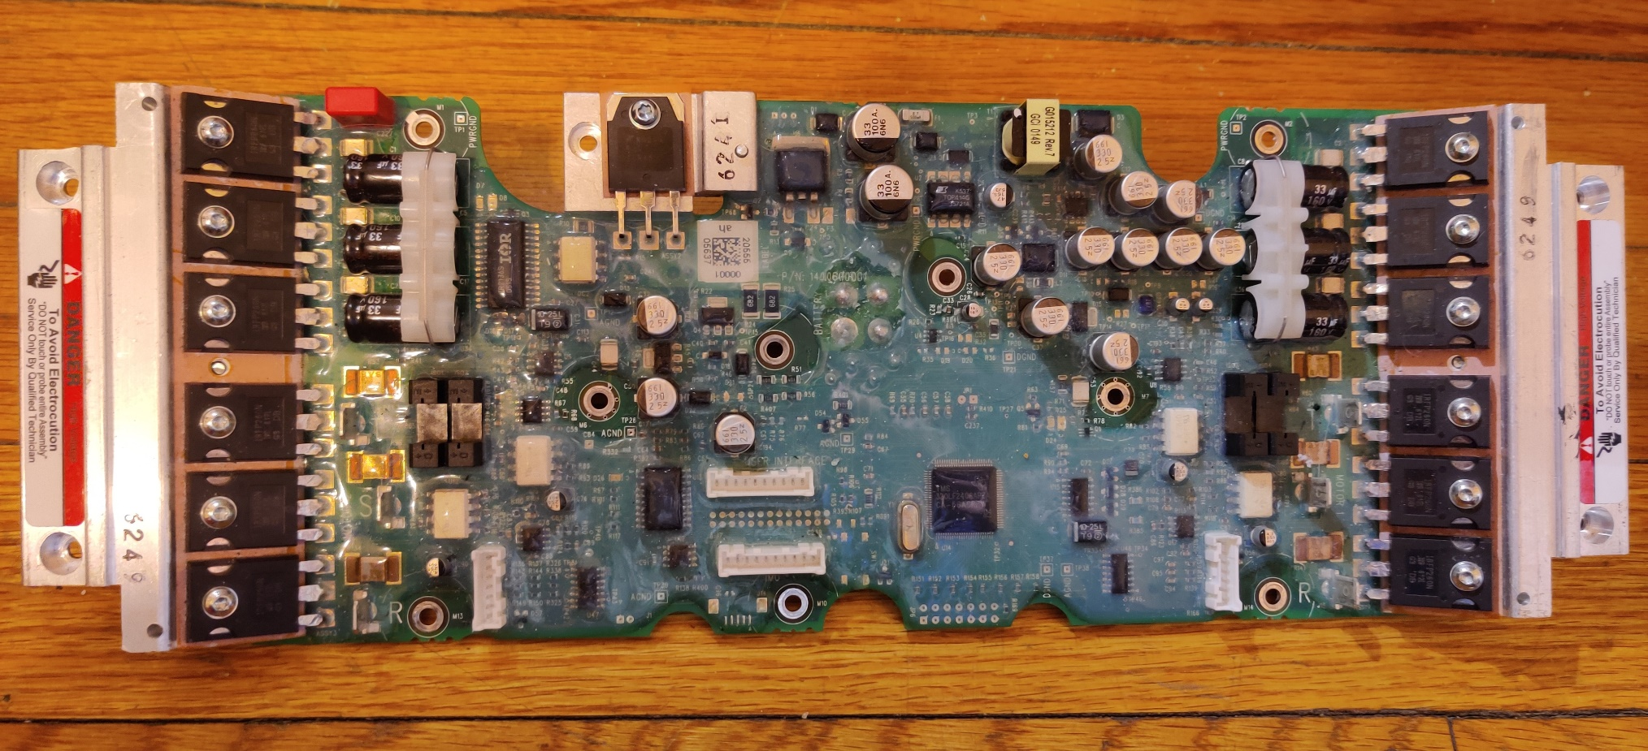

A 7840 0611

Ref: #13

A 7840 0611

Ref: #13

CRLNLMG1 32B1M

Ref: #17

56A504M HCT04

Ref: #7

59A2VHM TLC2254

Ref: #9

TMS 320LF2406APZA CA-56ACRFW 64

Ref: #25

P56AB 98752

Ref: #23

24C04WQ K525W

Ref: #2

59A2VHM TLC2254

Ref: #9

CRLNLMG1 32B1M

Ref: #17

A 7840 0611

Ref: #13

A 7840 0611

Ref: #13

37021 58MCD29

Ref: #4

37021 58MCD29

Ref: #4

56A504M HCT04

Ref: #7

56A5NLM HCT4051M

Ref: #8

56A5NLM HCT4051M

Ref: #8

56A5NLM HCT4051M

Ref: #8

CHAQ LMC64 82AIM

Ref: #16

66C1HCM HCT4053M

Ref: #10

37021 58M C66L

Ref: #3

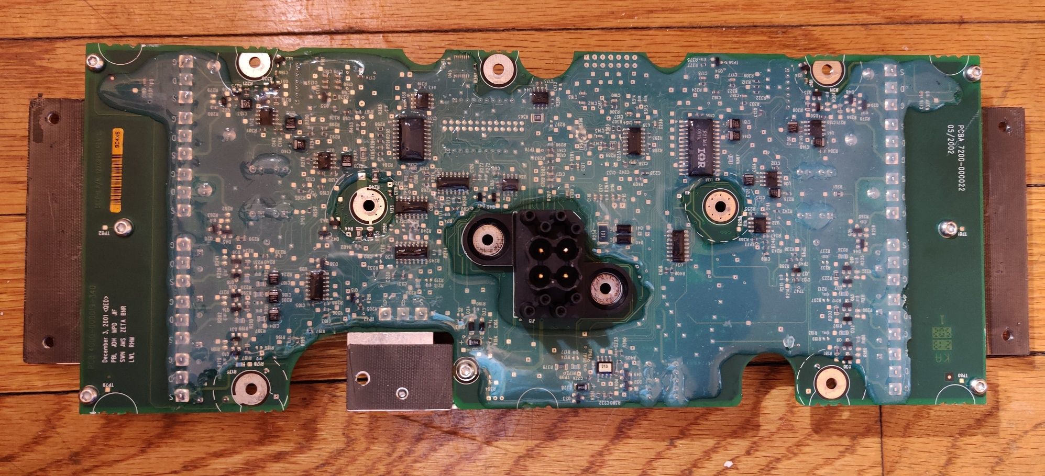

BL05A POIB8

Ref: #15

BL05A POIB8

Ref: #15

P185B MM74HCT 244WM

Ref: #22

24C04WQ K525W

Ref: #2

A82C250 4R4T0 n5064

Ref: #14

IR 2136S 0515

Ref: #18

16126797 AU195 02 UnNQ540B

Ref: #1

8L05A POIB8

Ref: #12

8L05A POIB8

Ref: #12

TMS320 980 F2808ZGHA

Ref: #26

TMS320 980 F2808ZGHA

Ref: #26

ATMEL620 25P1024

Ref: #29

LC07A 63K E01R

Ref: #27

LC07A 63K E01R

Ref: #27

VD251 58M L6E

Ref: #28

